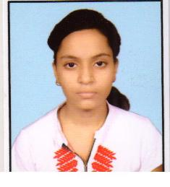
RESUME

POOJA KUSHWAHA
D63/13, ANNPURANA COLONY
MAHMOORGANJ,VARANASI
Mob.:No. 7068148260

Objective :
To work in an organization for its growth with best of my knowledge and experience.
Education Qualification:
- High School from U.P. Board in 2017
Computer Skills:
- Basic Computer Knowledge
- Internet.
- Type writing English
Personal Profiles:

Father's Name : Mr. Manoj Kushwaha
Mother's Name : Smt. Baby Kushwaha
Date of Birth : 14/10/1999
Religion : Hindu
Sex : Female
Nationality : Indian
Language : Hindi

Marriage status : Unmarried
Date : 05-June-2017
Place : Varanasi (Pooja Kushwaha)

